Issue 1: Data differences between Hardware and Snapshot Asset cubes for the Current Month.

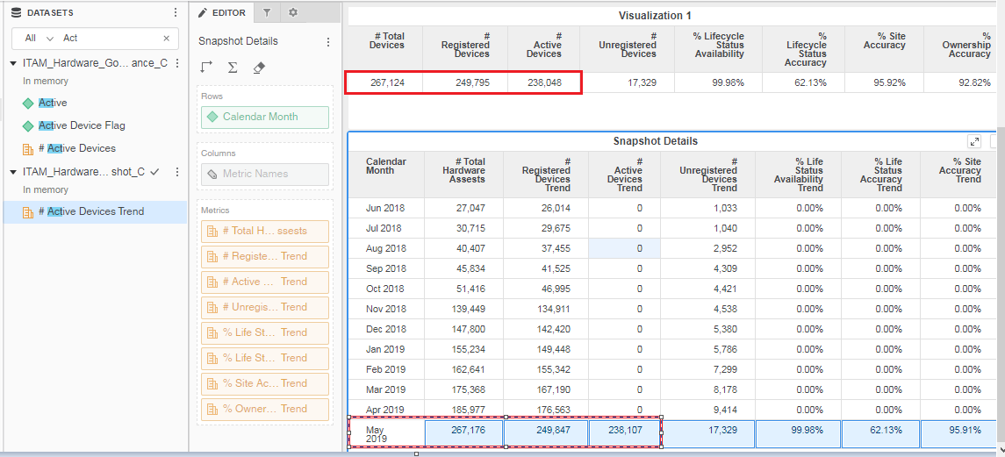

Issue 2: Department Attribute is having NULL’s for both Service now and Tenable.

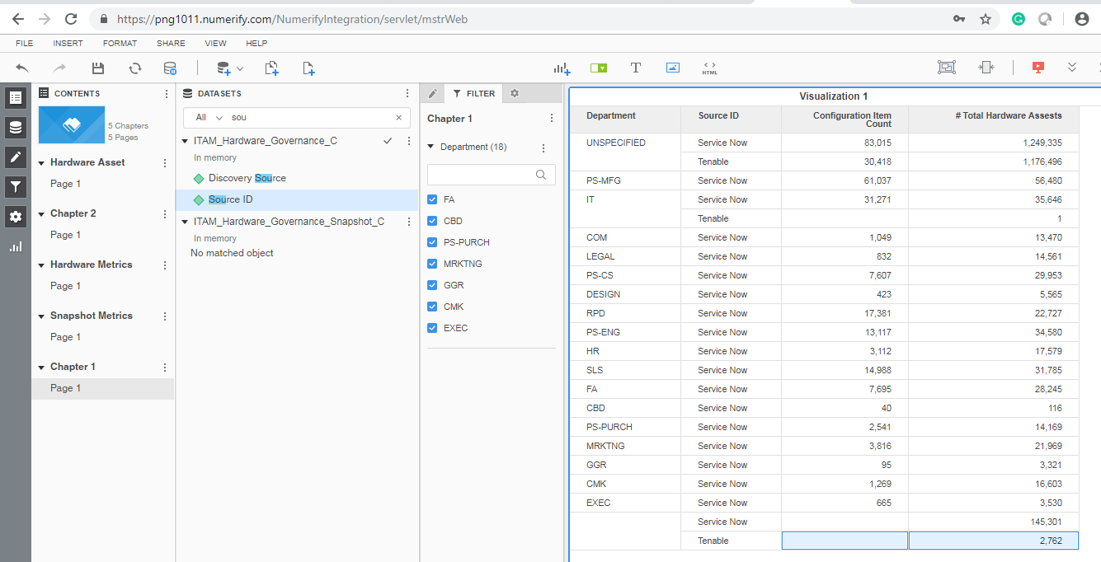

Issue 3: Device Type is Null for the Tenable records.

Issue 4 : VLAN Description attribute is displaying nulls.

pOIU

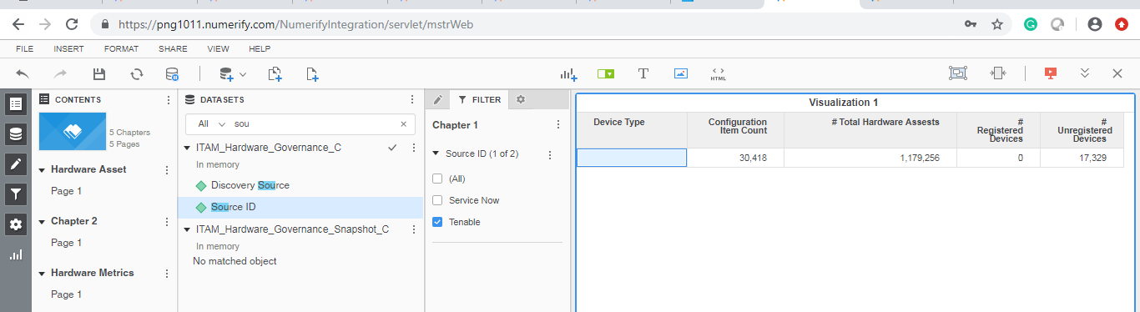

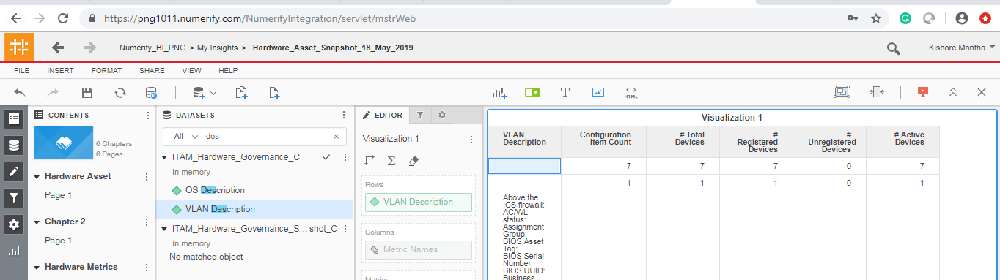

Issue 5 : Two rows are created for the Infoblox

select a.source_name_c as sourcename,

a.source_id as sourceid,

max(a.file_uploaded_date_time_c) as file_lastupdated

from png_mdwdb.d_source_available_schedules_c a

where

a.row_key > 0

GROUP BY a.source_name_c,a.source_id

